ALBs and ASGs for ChatApp across 3 AZs

1) Goal (one line)
Make the ChatApp highly-available and elastic by placing Web and App tiers behind two ALBs (Public ALB → Web ASG; Internal ALB → App ASG), with both ASGs spanning 3 AZs and auto-registering targets.

2) Network & subnets (foundation)
- VPC with 3 AZs: AZ-A, AZ-B, AZ-C.
- Subnets:
  - Public-A / Public-B / Public-C — for Public ALB and Web instances (auto-assign public IP enabled on launch template if needed).
  - Private-A / Private-B / Private-C — for Internal ALB, App instances, DB.
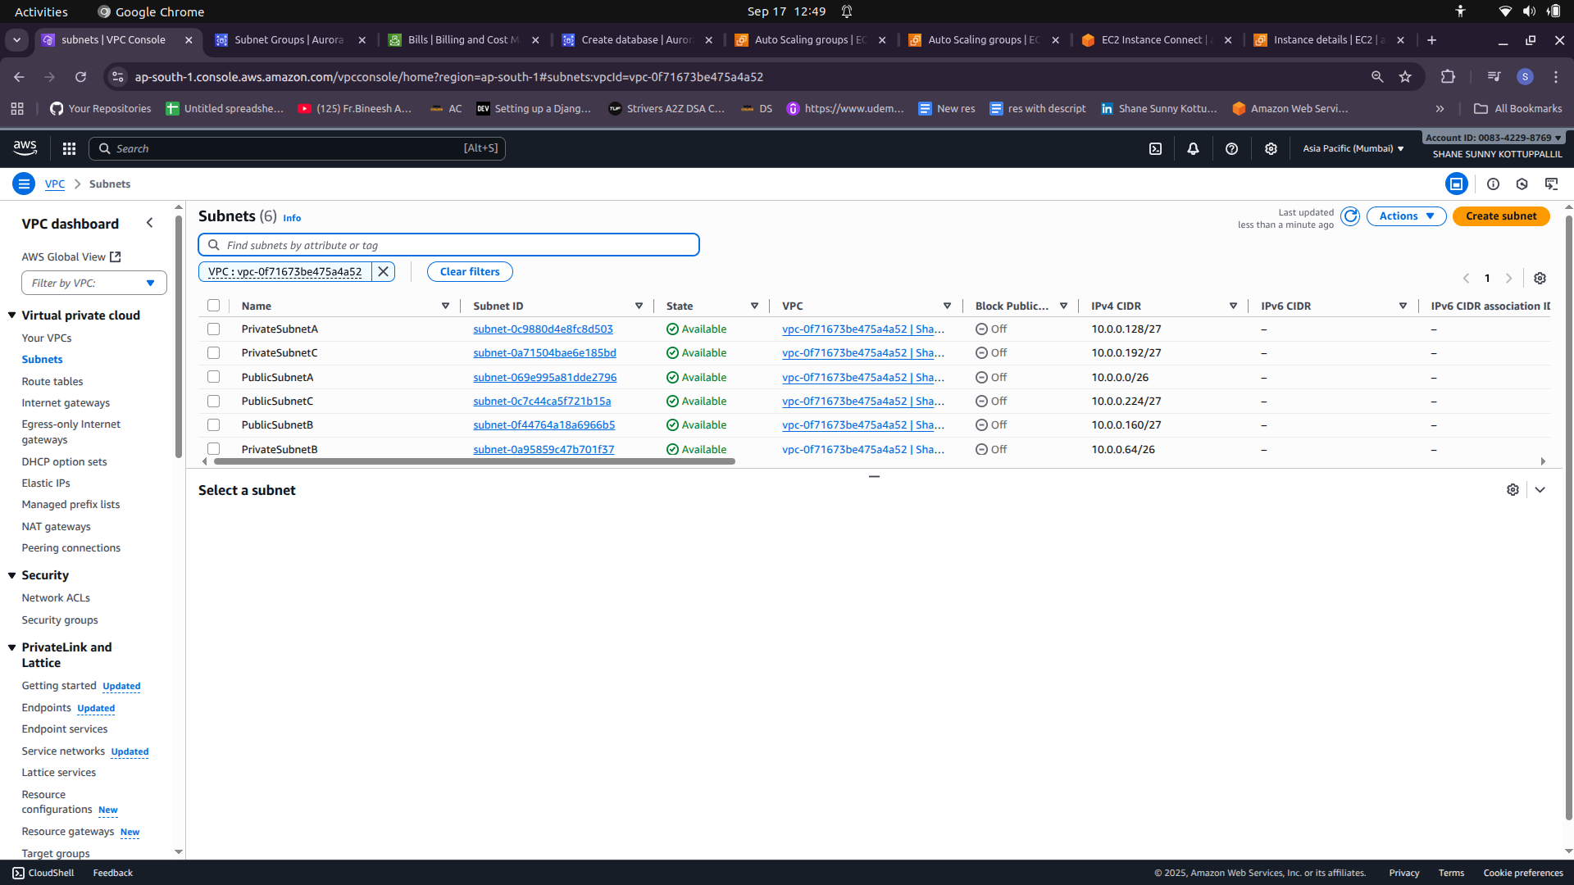
- Routing:
  - Public subnets → Route table → Internet Gateway (IGW).
  - Private subnets → Route table → NAT Gateway (per AZ if you want full AZ isolation, or single NAT for cost saving).

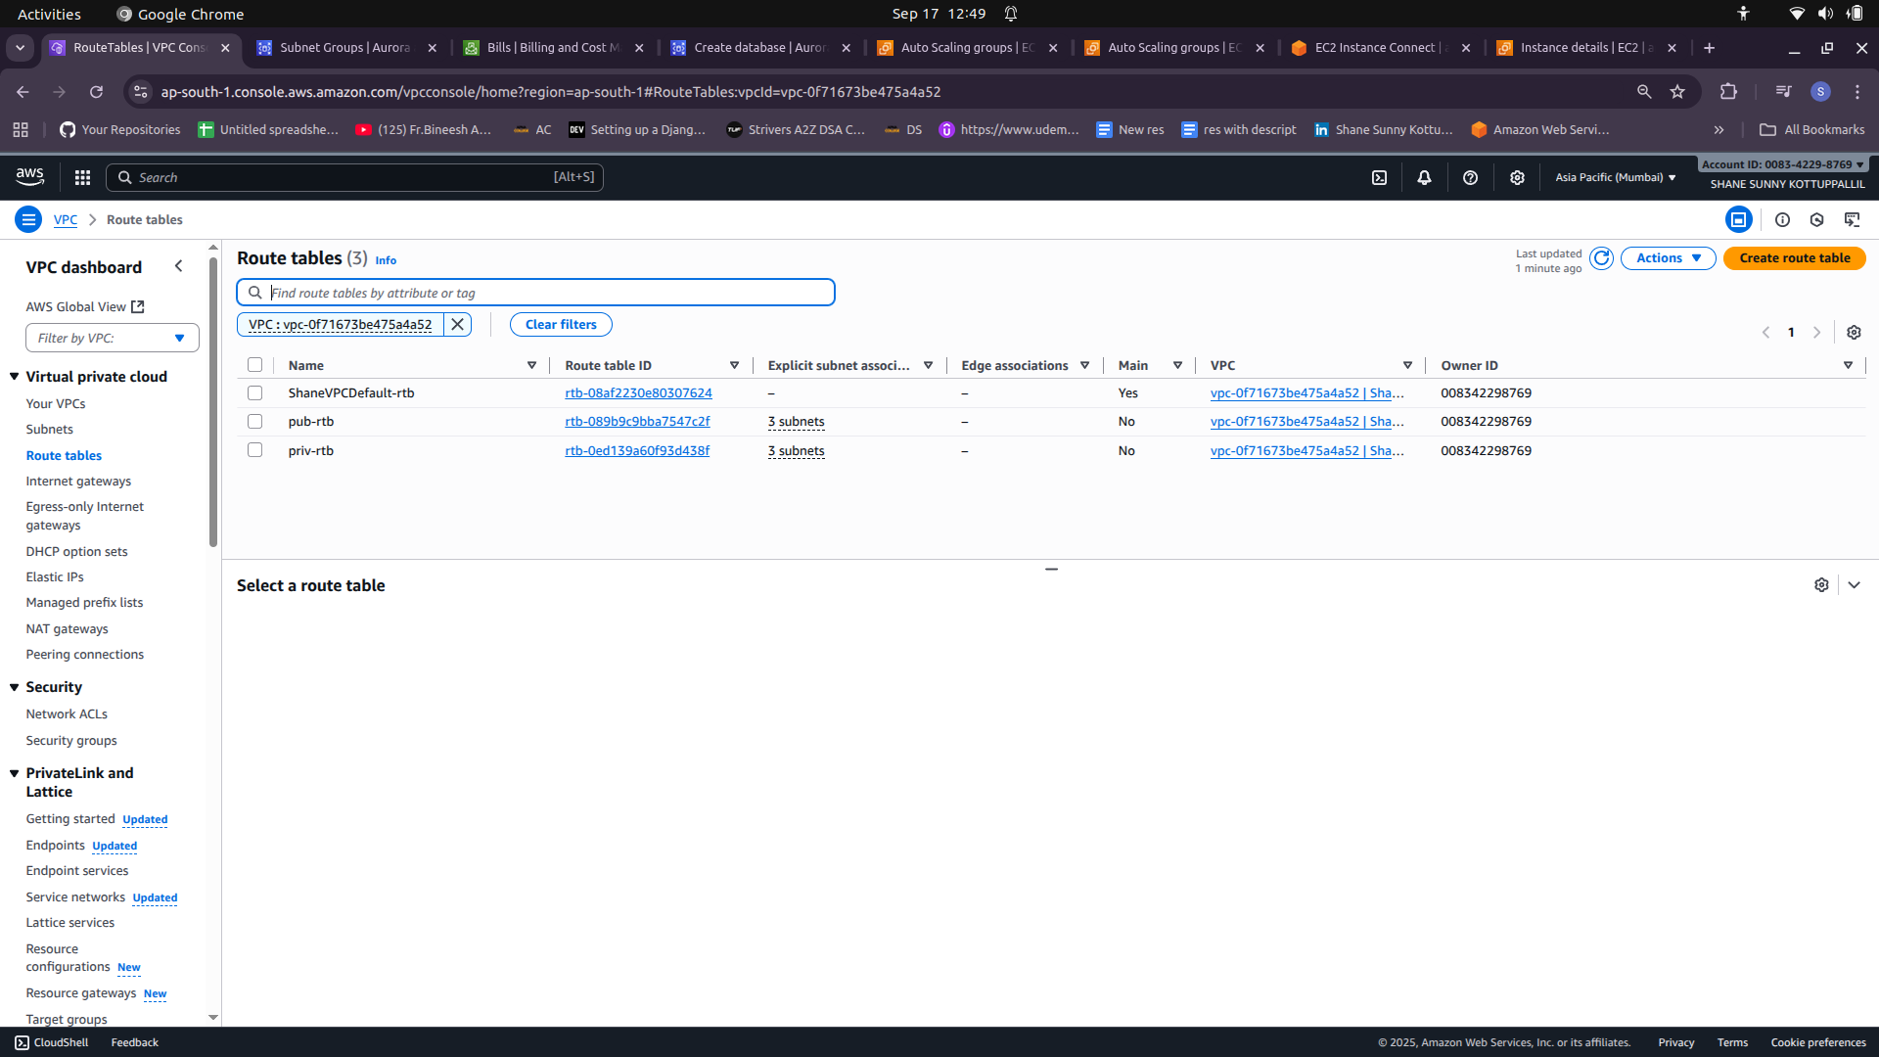

3) Security groups (least-privilege chain)
Create SGs and attach appropriately.
- alb-web-sg (Public ALB)
  - Inbound: TCP 80 from 0.0.0.0/0
  - Outbound: TCP 80 to chatweb-sg (or default all outbound)
- chatweb-sg (Web EC2 / Web ASG — Nginx)
  - Inbound: TCP 80 from alb-web-sg (source = SG ID)
  - Outbound: TCP 80 to alb-app-sg
- alb-app-sg (Internal ALB)
  - Inbound: TCP 80 from chatweb-sg
  - Outbound: TCP 8001 to app-sg
- app-sg (App EC2 / App ASG — Gunicorn)
  - Inbound: TCP 8001 from alb-app-sg
  - Outbound: TCP 3306 to db-sg (or general egress if using NAT)
- db-sg (MySQL)
  - Inbound: TCP 3306 from app-sg only
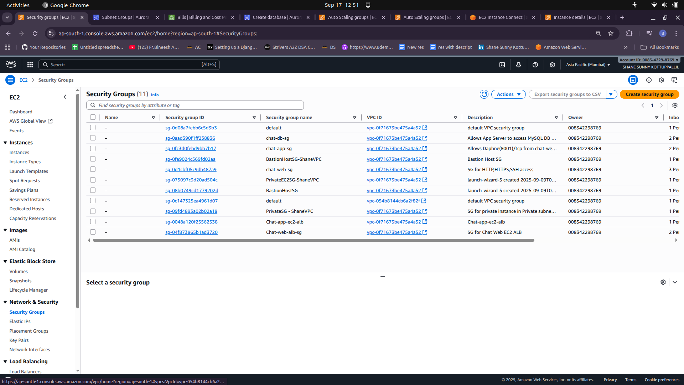
- Always reference SG IDs (not CIDRs) when restricting access between tiers.
- Keep SSH (22) locked to your admin IP or bastion SG if you need SSH.

4) Target Groups & Health Checks
Create two Target Groups (TG) per ALB:

TG-web (for Web ASG)
- Target type: Instance
- Protocol/Port: HTTP:80
- Health check:
  - Protocol: HTTP
  - Path: /healthz (served by Nginx)
  - Interval: 15s, Timeout: 5s, Healthy threshold: 2, Unhealthy threshold: 2
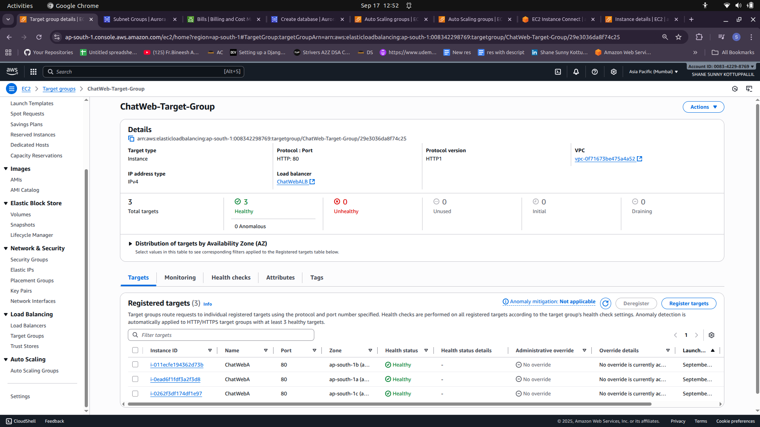

TG-app (for App ASG)
- Target type: Instance
- Protocol/Port: HTTP:8001 (or configure ALB listener on :80 and TG uses :8001)
- Health check:
  - Protocol: HTTP
  - Path: /healthz (Django view returning 200)
  - Interval: 15s, Timeout: 5s, Healthy/Unhealthy thresholds: 2
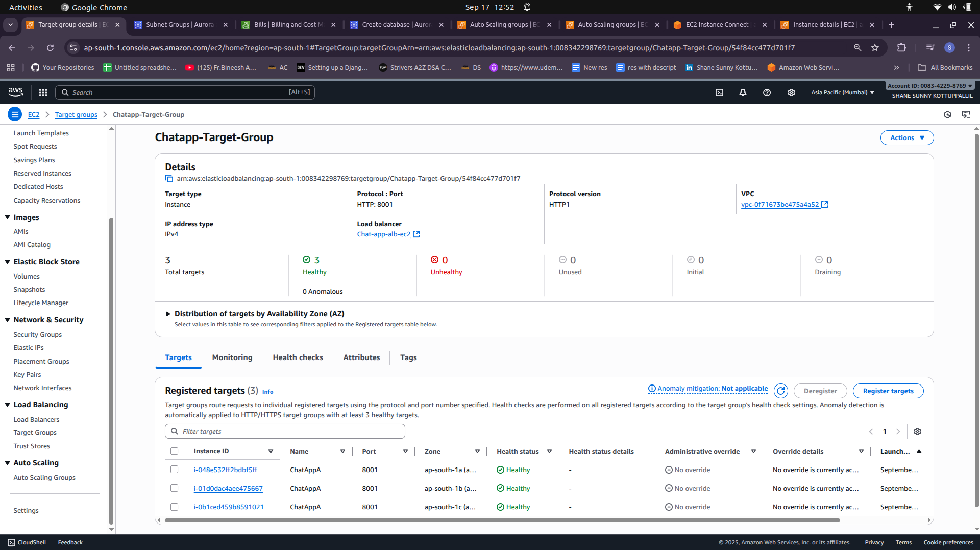

5) Create ALBs & listeners

Public ALB (Internet-facing)
- Scheme: Internet-facing
- Subnets: Public-A / Public-B / Public-C
- Security Group: alb-web-sg
- Listener: HTTP 80 → Default action: forward → TG-web
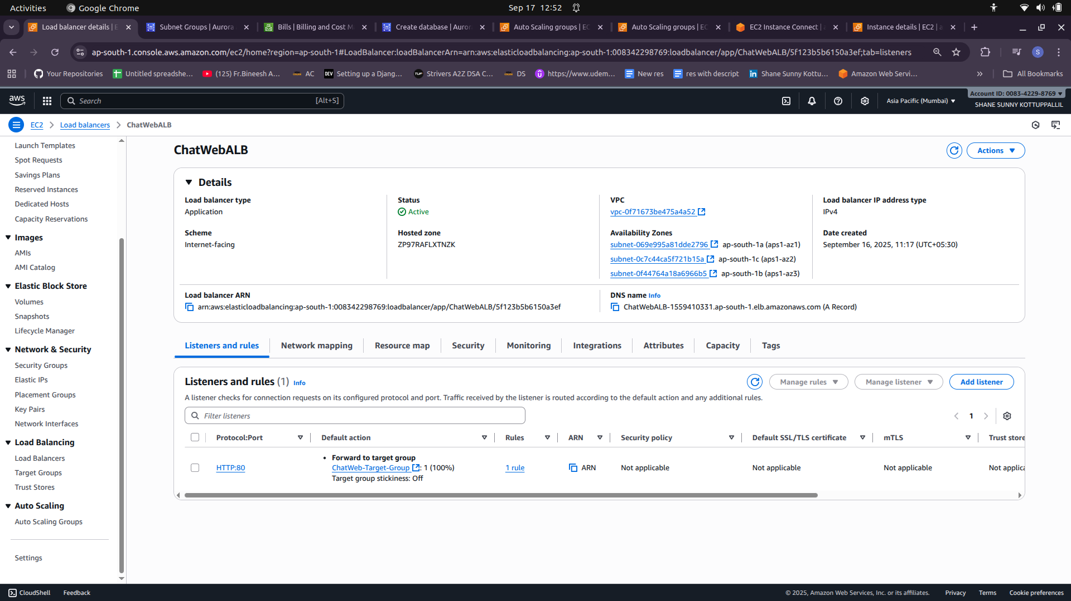
Internal ALB (private)
- Scheme: Internal
- Subnets: Private-A / Private-B / Private-C
- Security Group: alb-app-sg
- Listener: HTTP 80 → Default action: forward → TG-app
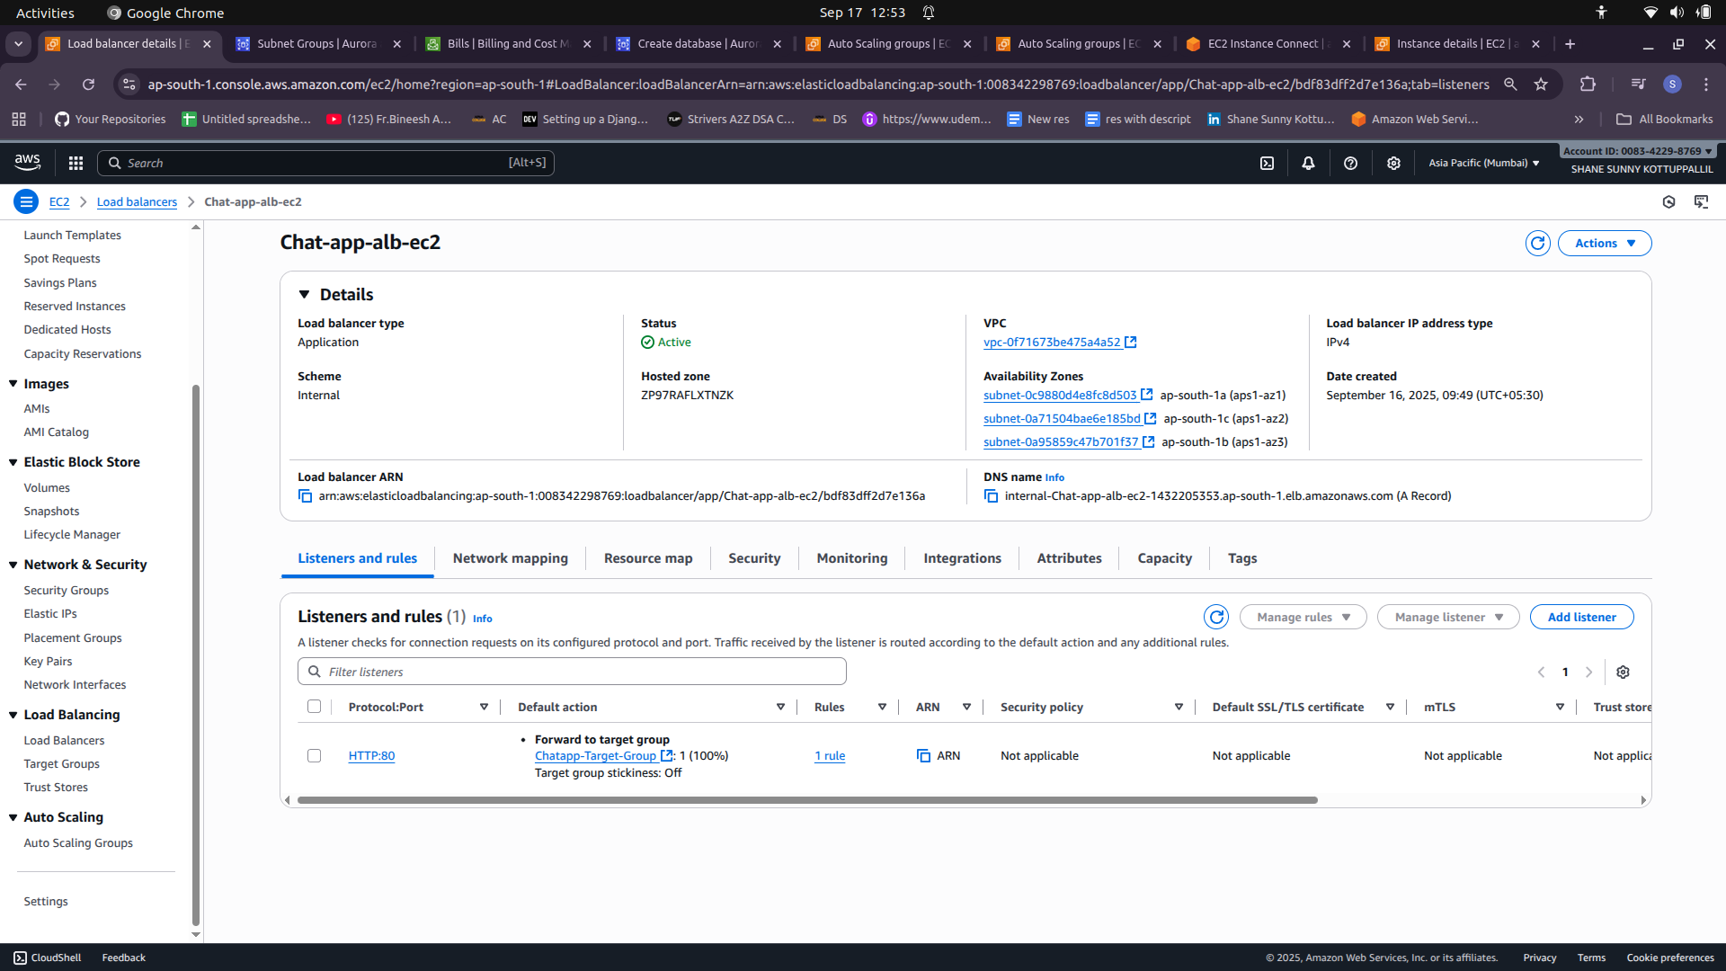

6) Create Launch Templates (one per tier)
Build a Launch Template that ASG will use. Two templates — LT-web and LT-app.

Common Launch Template fields
- AMI: use your baked AMI that has Nginx (web) or Gunicorn + app (app). If AMI is not baked, include user-data to bootstrap from repo.
- Instance type: chosen per load/bench.
- Key pair: for ssh
- IAM instance profile: role with minimal permissions (CloudWatch agent, S3 read if pulling config, EC2 CreateTags if doing dynamic naming).
- Security group: chatweb-sg for LT-web; app-sg for LT-app.
- User-data: optional safety script — ensure service is enabled/started.
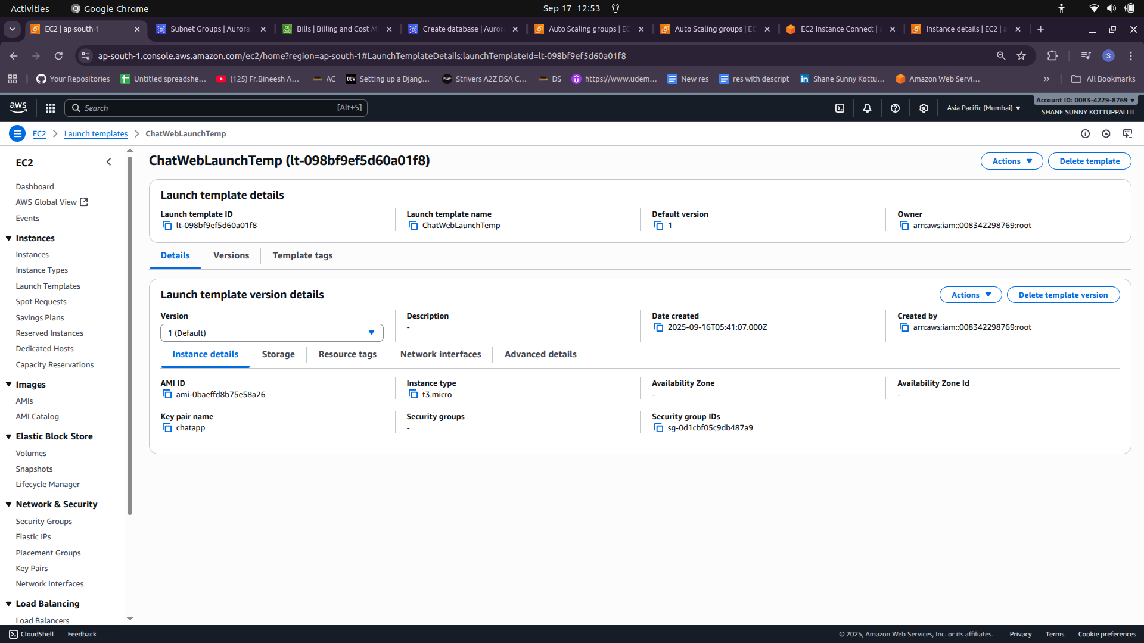
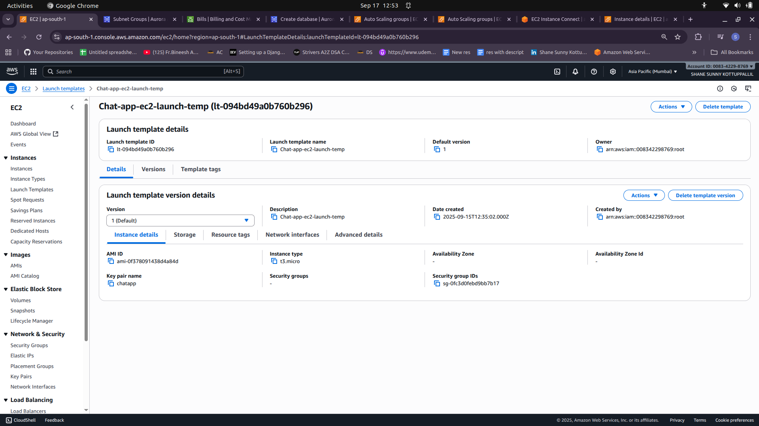

7) Create Auto Scaling Groups (ASGs)

ASG-app (App tier)
- Launch template: LT-app
- VPC subnets: Private-A / Private-B / Private-C
- Attached target group: TG-app
- Health checks: ELB (use ALB health status) and EC2
- Health check grace period: 90–120s (Gunicorn warm-up)
- Desired capacity: 2 (for 3 AZs, keep at least 1 per AZ)
- Min capacity: 3
- Max capacity: 6
- Instance warm-up: 120s
- Deregistration delay on TG: 60–120s (so in-flight requests drain)
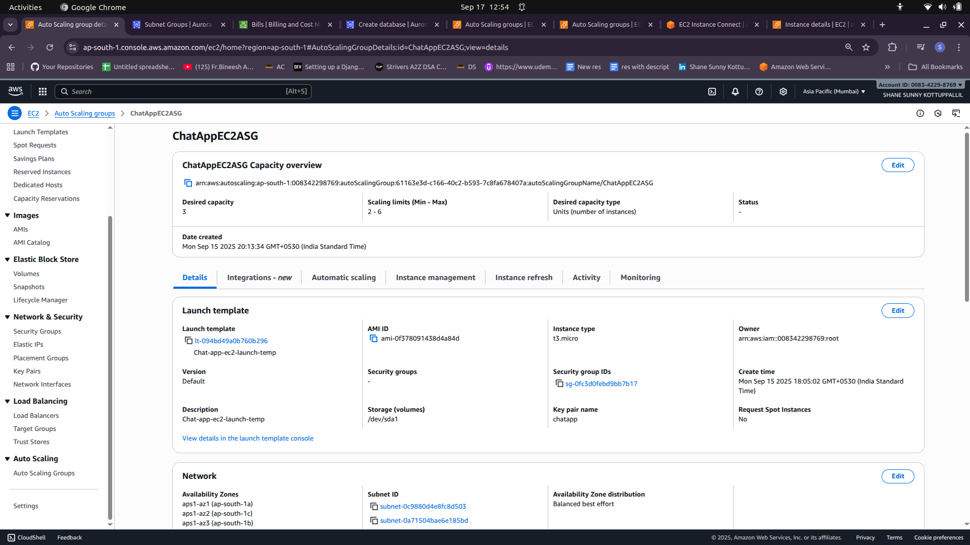

ASG-web (Web tier)
- Launch template: LT-web
- VPC subnets: Public-A / Public-B / Public-C
- Attached target group: TG-web
- Health checks: ELB
- Grace period: 60s
- Desired: 3, Min: 3, Max: 6 (example)
- Warm-up: 60s
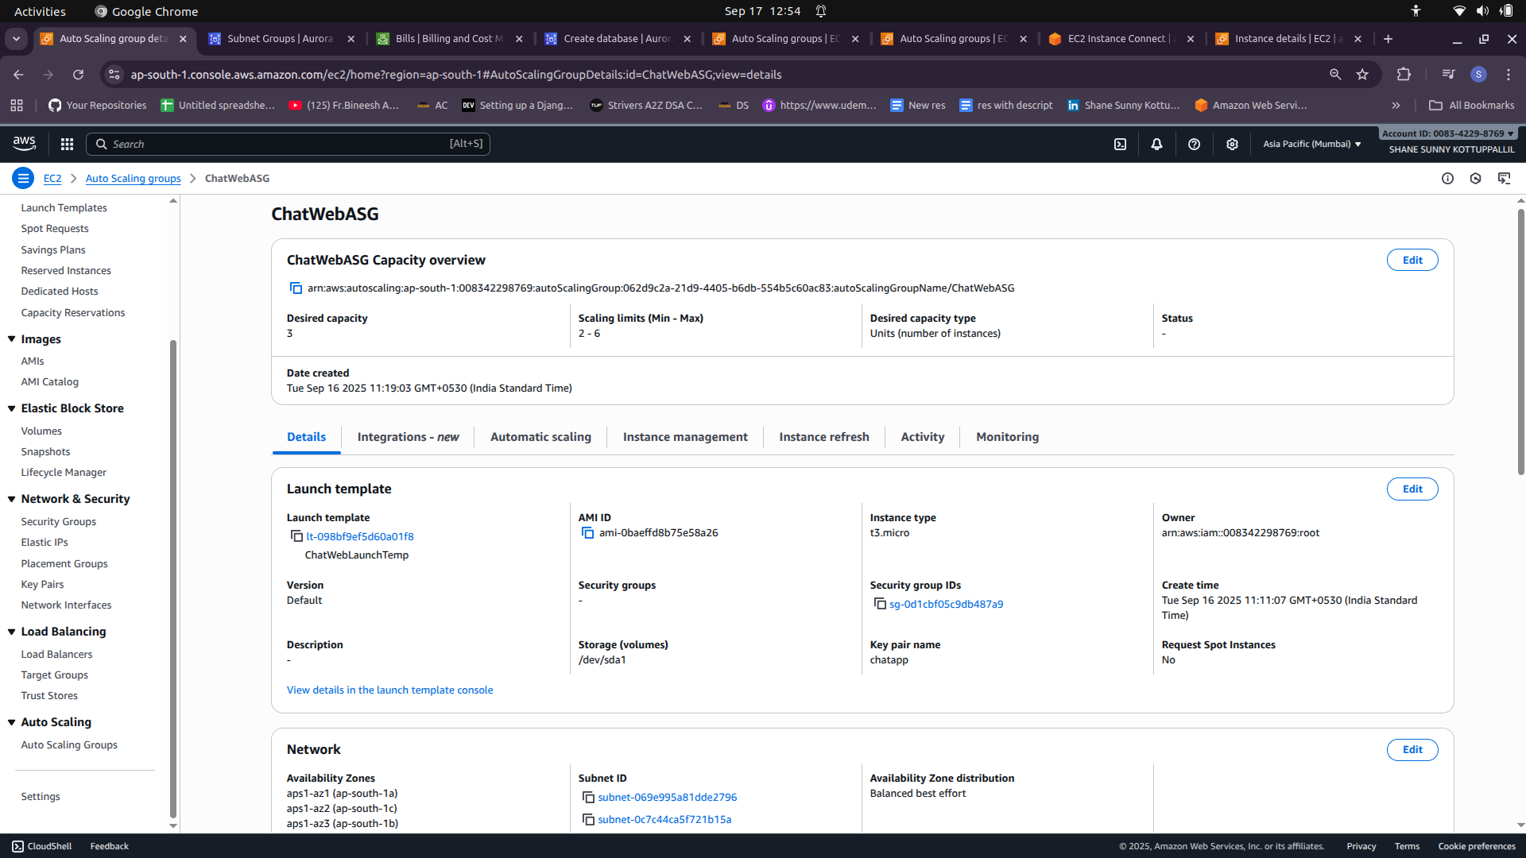
- When creating ASG, choose “Attach to existing load balancer / target group” so instances are auto registered.

8) Wiring Nginx on Web EC2s → Internal ALB
Do not hardcode App instance IPs. Point Nginx upstream to the Internal ALB DNS:
upstream fundoo_wsgi {
#server 10.0.0.147:8001;
server internal-Chat-app-alb-ec2-1432205353.ap-south-1.elb.amazonaws.com:80;
keepalive 64;
}

server {
listen 80;
server_name _; # swap with your domain later
# Basic health
location = /healthz { return 200 'ok'; add_header Content-Type text/plain; }

location / {
proxy_pass http://fundoo_wsgi;
proxy_http_version 1.1;
# http {} or server {} block
add_header X-Instance-Hostname $hostname always;
add_header X-Instance-IP $server_addr always;
proxy_set_header Host $host;
}
}

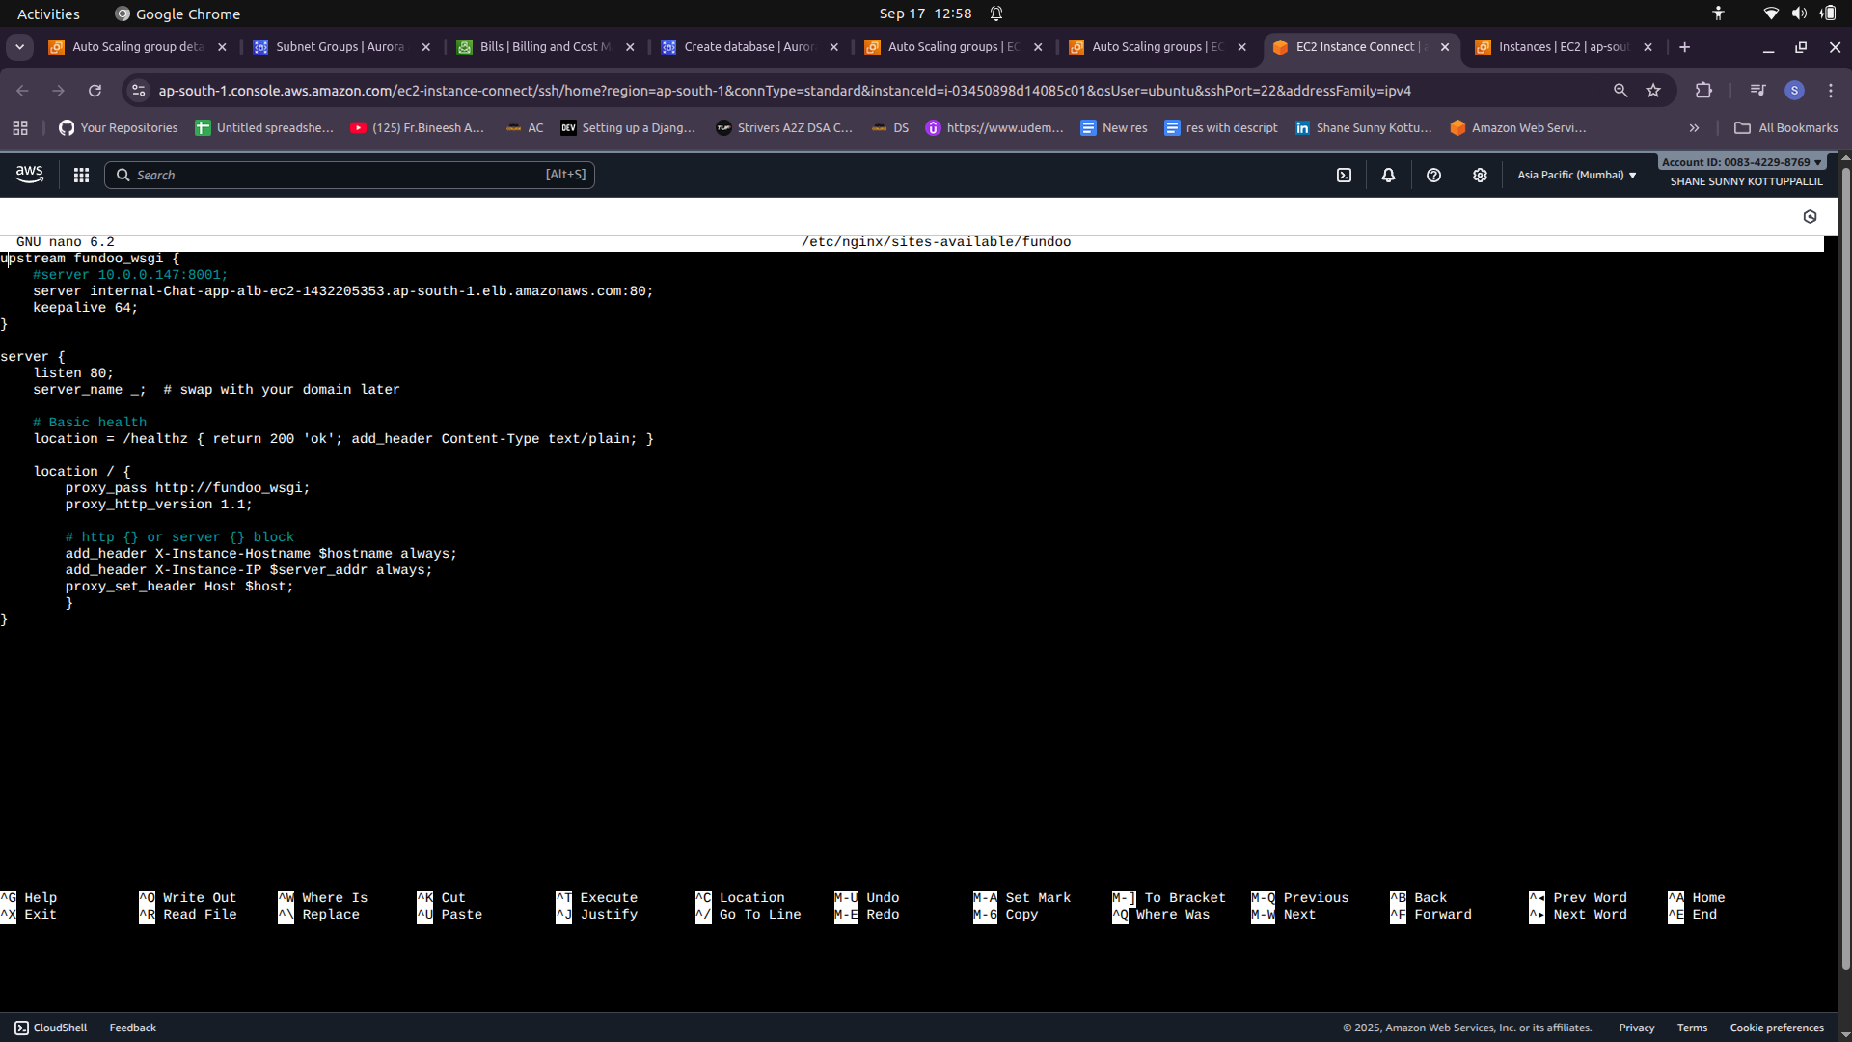
- Bake this config into the Web AMI or drop via user-data.

9) Verify & test step-by-step

A. DNS & listener
- nslookup ChatWebALB-1559410331.ap-south-1.elb.amazonaws.com → should resolve to several IPs.
- curl -I http://ChatWebALB-1559410331.ap-south-1.elb.amazonaws.com/ → expect 200 OK once targets healthy.

B. Target group health
- Console: EC2 → Target Groups → show HealthyHostCount. Should match ASG desired (3).
- If unhealthy, inspect Status reason (connection timed out/refused/404).

C. Validate per node
SSH into a Web node:
- sudo ss -ltnp | grep ':80' — Nginx listening on 0.0.0.0:80
- curl -I http://127.0.0.1/healthz — expect 200
- curl -I http://internal-Chat-app-alb-ec2-1432205353.ap-south-1.elb.amazonaws.com/healthz — from Web node, expect 200
On App node:
- sudo ss -ltnp | grep ':8001' — Gunicorn listening
- curl -I http://127.0.0.1:8001/healthz — expect 200

10) Scaling policies & tuning
- Web ASG: Target tracking on ALBRequestCountPerTarget (e.g., target 700 requests/target).
- App ASG: Target tracking on ASGAverageCPUUtilization (e.g., 60%).
- Configure cooldowns / warm-up as above.
- Monitor CloudWatch metrics: UnHealthyHostCount, HTTPCode_Target_5XX_Count, RequestCount, GroupInServiceInstances.

